Toothaches are among the most common reasons children experience oral discomfort, often catching parents off guard. While it may seem like a minor issue, untreated dental pain can rapidly escalate into more serious problems, including infections and long-term damage. We understand how distressing it can be to see your child in pain. That’s why we’re committed to providing timely, compassionate care to families across the Ottawa and Gatineau area—ensuring every child receives the attention they deserve when dental issues arise.
Recognizing the Signs of a Toothache in Children
Children may not always articulate their discomfort clearly, especially if they’re young or non-verbal. Some common signs of a toothache in children include:
● Crying or irritability
● Refusal to eat or chew on one side of the mouth
● Swollen cheeks or gums
● Trouble sleeping
● A low-grade fever
● Tugging at the jaw or rubbing their cheek
Early identification is key to minimizing pain and preventing the problem from escalating.
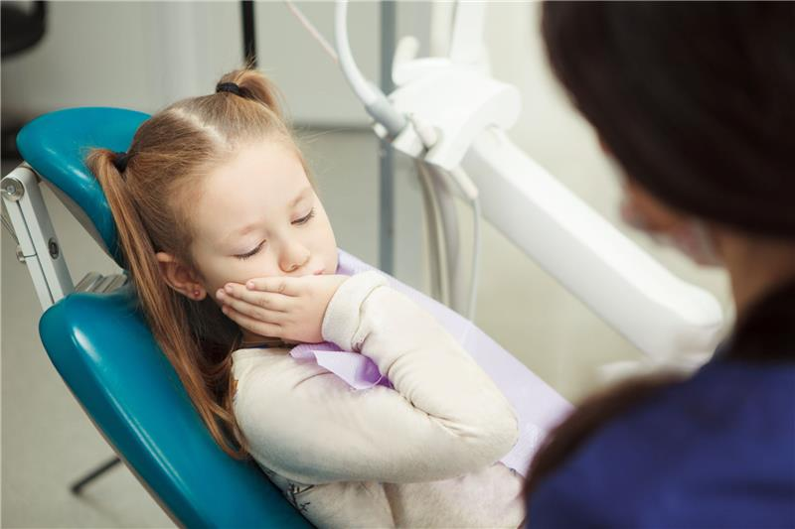
Immediate Actions to Relieve Your Child’s Toothache
Before visiting the dentist, there are a few steps you can take at home to ease your child’s discomfort:
1. Rinse with Warm Salt Water
Mix a teaspoon of salt in a cup of warm water and have your child gently swish it around their mouth. This natural remedy helps reduce inflammation and flush out bacteria.
2. Use a Cold Compress
Apply a cold compress or ice pack to the outside of your child’s cheek near the affected area. This can help reduce swelling and numb the pain.
3. Administer Over-the-Counter Pain Relief
Use child-safe pain medications like acetaminophen or ibuprofen, following dosage instructions. Avoid placing aspirin directly on the tooth or gums.
4. Inspect for Visible Causes
Look for food debris stuck between teeth, swelling, or visible cavities. Use dental floss gently to remove any trapped particles.
When to Call a Dentist Immediately
Some dental issues require urgent attention. Contact a professional dentist immediately if:
● Your child’s face is swollen
● There is a persistent fever
● The pain lasts more than 24 hours
● There’s a visible abscess or pus
● Your child has suffered a traumatic injury to the tooth or mouth
We prioritize emergency appointments for children in pain to provide immediate relief and treatment.

Common Causes of Toothaches in Children
Understanding the root cause of your child’s toothache can help prevent future issues:
1. Cavities
Tooth decay is the most common reason for toothaches in children. Poor brushing and sugary diets contribute heavily to cavity formation.
2. Gum Infections
Gingivitis and other gum-related infections can cause pain and swelling around the tooth line.
3. Tooth Eruption
New teeth pushing through the gums, especially molars, can lead to temporary discomfort.
4. Dental Trauma
Falls or accidents may cause internal tooth damage not visible to the naked eye.
What to Expect at Larkspur Dental
At Larkspur Dental, we are equipped to diagnose and treat all types of childhood dental pain with care and precision.
Comprehensive Assessment
We conduct a full examination, including digital X-rays if needed, to identify the source of the pain.
Gentle Pediatric Treatment
Our team uses a calm, compassionate approach tailored for young patients. Treatments may include fillings, fluoride applications, extractions, or antibiotics for infection control.
Preventative Guidance
Once the pain is resolved, we guide parents on improving oral hygiene routines and diet to avoid future toothaches.

